AUTOMATIC CLUTCH AND BRAKE SYSTEM FOR FOUR WHEELERS
Abstract:
Pneumatics operation technology now-a - days widely used in all kind work related with compressed air. The knowledge from timber work to robot technology it is used with so advanced and also with automation. It is therefore very essential and important for any technicians or engineers to get a better knowledge of pneumatic system, air operated valves and others. The compressed air from the compressor pass through medium and to the cylinder by a pipe line fabrication. To achieve maximum work done of pneumatic system, it is of importance that pressure drop between generation and consumption of compressed air is kept minimum. This project is to develop a control system along with an effective electronic controlled automotive braking and clutch method is called “Automatic pneumatic clutch and braking system”. Pneumatic Brake and clutches operated though sensors which with IR transmitter and Receiver unit, Control Unit, and Pneumatic breaking system. The IR sensor is to find the resisting area and obstacle. If there is any resisting in the passage , the IR sensor senses the proximity and obstacle and giving the control signal to the breaking and clutch system. The pneumatic breaking and clutch system is used to break the vehicle and clutch to shift the gear system.
Existing theory:
To reduce the speed of the vehicle or to stop brake is a common device. This mechanical tool reducing the speed or stopping the movement of an object. By using friction between two contacting surfaces by pressing together, then convert the kinetic to static condition with elevation of some heat. Here one method of energy conversion is employed in this project is Eddy current Eddy current brake is a break used in magnetic fields to change dynamic energy into electric current in the brake unit, which is applied with better efficiency and low power consumption. Break applying in a very high speed vehicle such as race car or jet aero plane or parachute with gravitational force, Breaks are mainly applied to rotating parts, but it may also be in other forms as the surface of a moving fluid (water or air). In this project eddy current is used to make effective action of break in rotating wheel.
Proposed theory:
The infra red rays reflected, if any prevention is there in the path. “IR receiver” receives the signal of infra-red rays reflection from the IR transmitter unit which transmits the Infra-Red rays. [10-16] The control circuit will get control signal from IR rays which reflects from IR receiver circuit. Solenoid valve will get activation from control circuit. When the solenoid valve is functioned to activate, the compressed air flows to the Double Acting Pneumatic Cylinder. Then the air pressed the pneumatic cylinder to move the piston rod.[17-25] The breaking arrangement will function when the piston moves forward and break the wheel slowly or rapidly by moving of piston . “Flow control valve” will vary the breaking speed by adjusting the valve.[26-27] In this project, the breaking arrangement is in a wheel as a model. The compressed air from the compressor flow through the hose tube to the flow control valve. The flow control valve is connected to the solenoid valve which control the entire system.[28-30] 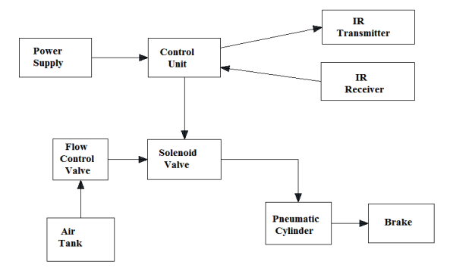
Conclusion:
This project work has provided us with excellent opportunity and experiences to use our limited Knowledge. We gained much practical knowledge regarding planning, purchasing assembling and machining while doing this project work. We feel that the project work is an excellent solution to bridge the gates between institutes’ and industries. We are proof that we have completed the work with a limited time successfully . the automatic clutch and braking system are working with satisfactory condition . we can understand and difficulties in maintains the tolerance and also quality. We have done our ability and skill , making maximum use of available facilities

